Software Engineering

Assignment #3

BSEE21078 Muhammad Inshal Rizwan

BSEE21065 Adeena Ali

BSEE21048 Muhammad Subhan

Q1:Develop the Structural Model of the system as proposed in assignment 1 and assignment 2. [Make sure to cover all the use cases of the system]

Class Diagram:

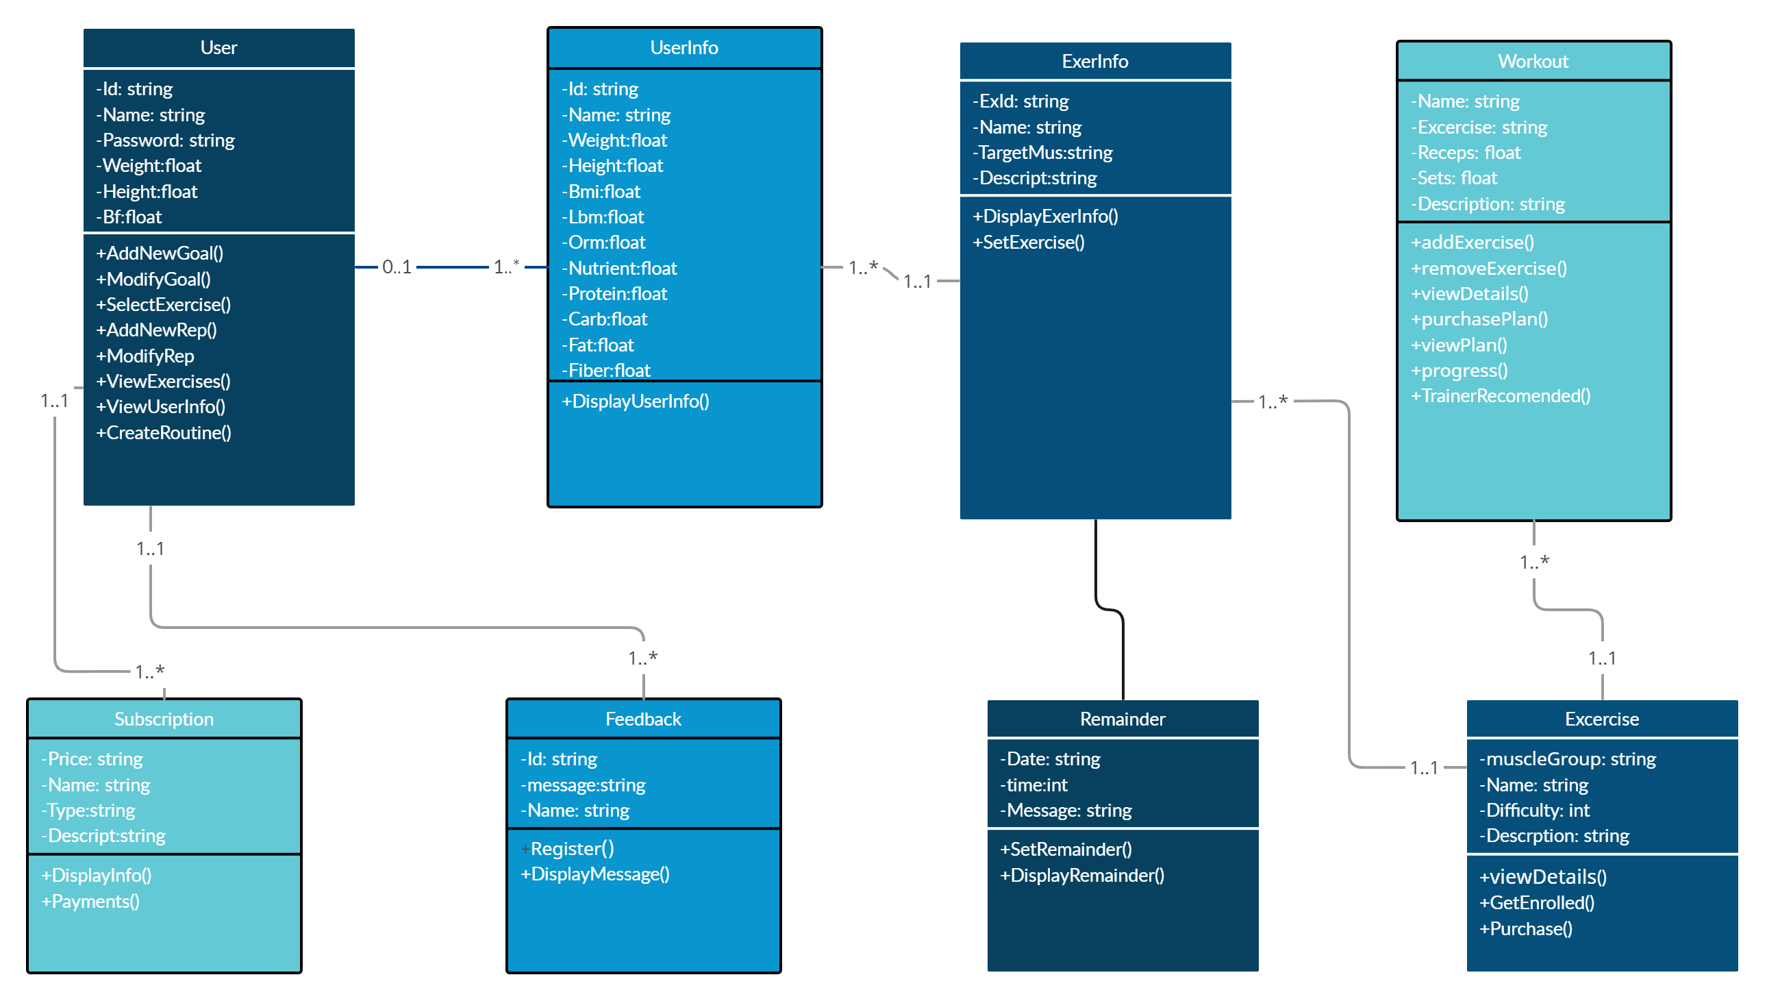

* User: has a Subscription, multiple Workouts, and multiple CustomWorkouts. Can select, customize, and track progress for Workouts, cancel Subscription, view WorkoutHistory, set WorkoutReminder, share WorkoutProgress, provide Feedback for Workouts, view WorkoutRecommendations, purchase WorkoutPlans, and connect with PersonalTrainers.
* Subscription: is owned by a User. Can be renewed or canceled.
* Exercise: is used in multiple Workouts and CustomWorkouts. Can be viewed in detail. has multiple Exercises. Can add and remove Exercises
* Workout: is owned by a User and can have multiple Exercises. Can be viewed in detail.History belongs to a User and references a Workout. Can be viewed in detail.
* Reminder: belongs to a User. Can be set or canceled.
* Feedback: belongs to a Workout. Can be submitted.
* PersonalTrainer: can be connected with by a User. Can have a profile viewed and sessions scheduled. WorkoutRecommendation: can be viewed by a User. WorkoutPlan: is purchased by a User and includes multiple Workouts. Can be viewed in detail.

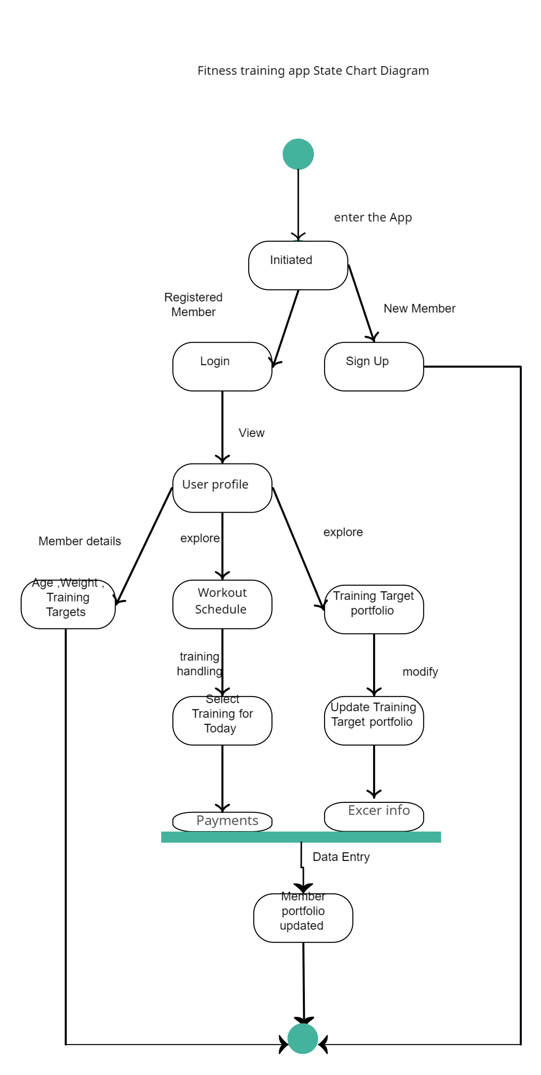

**T**his state diagram shows the possible states and transitions for the user's interactions with the app. The initial state is "User Logged In", which leads to two possible actions: "Create accountt" and "Log in".

If the user chooses to create a workout, the app transitions to the "Workout Created" state, which provides two options: " Workout Details" and " Workout schedule". If the user chooses to edit the workout details, the app transitions back to the "Workout Created" state. If the user chooses to schedule the workout, the app transitions to the "trainer portfolio" state. Then payments and trainers selections.and then to update the profile.

From the " update the profile." state, the only option is to "Log In Again", which takes the user back to the "User Logged In" state, starting the cycle again.

**Develop the Dynamic Model of the system. [Make sure to cover all the use cases of the system]**

**Sequence diagram**

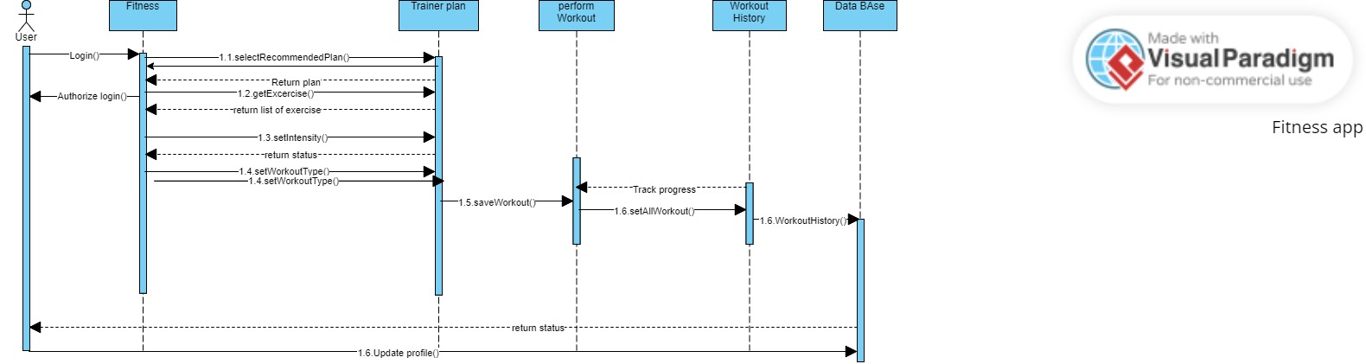

Interface and interaction diagram

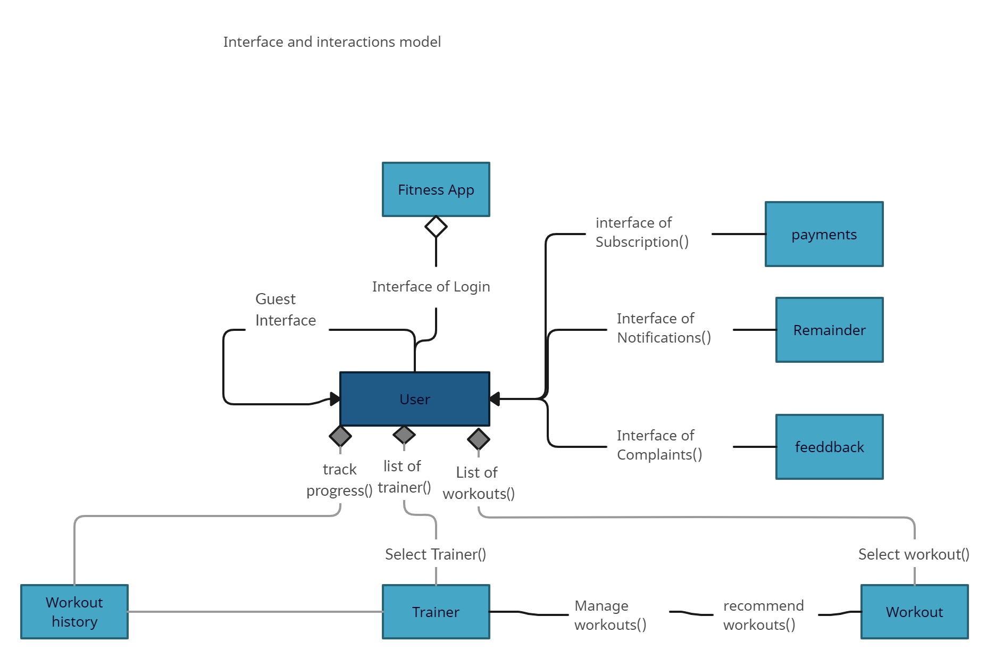

In this diagram, we have interfaces that represent the interactions between different components of the fitness training app. The User Interface is the interface that the user interacts with to use the app. The Fitness Controller is the component that controls the app's functionality and interacts with the database to store and retrieve data. The Exercise Interface, Workout Interface, and Progress Interface are interfaces that allow the user to interact with the different parts of the app, such as creating and modifying exercises, creating and modifying workout routines, and tracking progress.

* In this interaction, the User selects a workout from the app's user interface. The Workout object returns the workout details to the User object.
* The User object then selects an exercise from the workout and requests the Exercise object to return its details.
* The workout object returns the exercise details to the User object.
* The User object then starts the ProgressTracker object to track their progress during the exercise. As the user completes the exercise, the Exercise object records the completion and updates the ProgressTracker object. The ProgressTracker object then updates the user's progress in workout history.
* There are different interface of payments and remainder and feedback which is accessible to the user object.